PIZZA SALES SQL QUERIES

1. KPI’s
2. **Total Revenue**

SELECT SUM(total_price) AS Total_Revenue FROM pizza_sales;

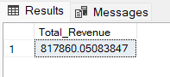

1. **Average Order Value**

SELECT SUM(total_price) / COUNT(DISTINCT order_id) AS Avg_Order_Value

FROM pizza_sales

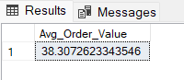

1. **Total Pizzas Sold**

SELECT SUM(quantity) AS Total_Pizza_Sold

FROM pizza_sales

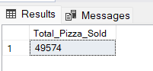

1. **Total Orders**

SELECT COUNT(DISTINCT order_id) AS Total_orders

FROM pizza_sales

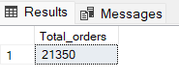

1. **Average Pizzas Per Order**

SELECT CAST(CAST(SUM(quantity) AS DECIMAL(10,2)) /

CAST(COUNT(DISTINCT order_id) AS DECIMAL(10,2)) AS DECIMAL(10,2))

AS Avg_Pizzas_per_order

FROM pizza_sales

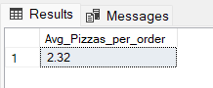

1. Daily Trend for Total Orders

SELECT DATENAME(DW, order_date) AS order_day, COUNT(DISTINCT order_id) AS Total_orders

FROM pizza_sales

GROUP BY DATENAME(DW, order_date)

***Output:***

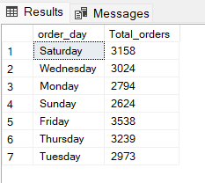

1. Hourly Trend for Orders

SELECT DATEPART(HOUR, order_time) AS order_hours, COUNT(DISTINCT order_id) AS Total_orders

FROM pizza_sales

GROUP BY DATEPART(HOUR, order_time)

ORDER BY DATEPART(HOUR, order_time)

***Output:***

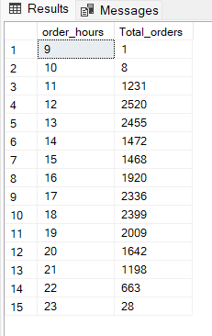

1. % of Sales by Pizza Category

SELECT pizza_category , CAST(SUM(total_price) AS DECIMAL(10,2)) AS Total_Revenue, CAST(SUM(total_price) * 100 / (SELECT SUM(total_price) FROM pizza_sales) AS DECIMAL(10,2)) AS PCT

FROM pizza_sales

GROUP BY pizza_category

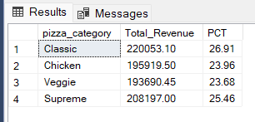

1. % of Sales by Pizza Size

SELECT pizza_size , CAST(SUM(total_price) AS DECIMAL(10,2)) AS Total_Revenue , CAST(SUM(total_price) * 100 / (SELECT SUM(total_price) FROM pizza_sales) AS DECIMAL(10,2))AS PCT

FROM pizza_sales

GROUP BY pizza_size

ORDER BY pizza_size

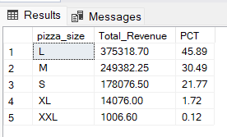

1. Total Pizzas Sold by Pizza Category

SELECT pizza_category , SUM(qunatity) AS Total_Quantity_Sold

FROM pizza_sales

WHERE MONTH(order_date) = 2

GROUP BY pizza_category

ORDER BY Total_Quantity_Sold DESC

*Output :*

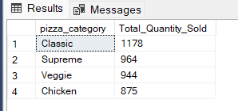

1. **Top 5 Pizzas by Revenue**

SELECT TOP 5 pizza_name , SUM(total_price) AS Total_Revenue FROM pizza_sales

GROUP BY pizza_name

ORDER BY Total_Revenue DESC

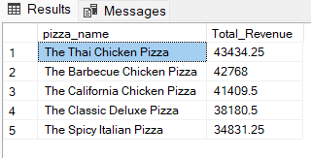

1. **Bottom 5 Pizzas by Revenue**

SELECT TOP 5 pizza_name , SUM(total_price) AS Total_Revenue FROM pizza_sales

GROUP BY pizza_name

ORDER BY Total_Revenue ASC

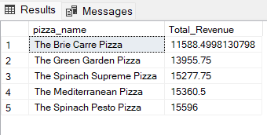

1. **Top 5 Pizzas by Quantity**

SELECT TOP 5 pizza_name , SUM(quantity) AS Total_quantity FROM pizza_sales

GROUP BY pizza_name

ORDER BY Total_quantity DESC

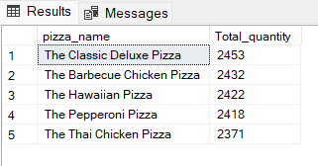

1. **Bottom 5 Pizzas by Quantity**

SELECT TOP 5 pizza_name , SUM(quantity) AS Total_quantity FROM pizza_sales

GROUP BY pizza_name

ORDER BY Total_quantity ASC

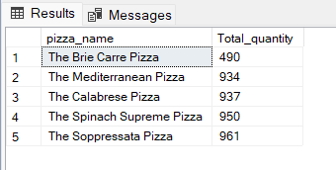

1. **Top 5 Pizza Sellers with respect to total orders:**

SELECT TOP 5 pizza_name , COUNT(DISTINCT order_id) AS Total_Orders FROM pizza_sales

GROUP BY pizza_name

ORDER BY Total_Orders DESC

